BMSim

IoT Fundamentals Course

Amirreza Hosseini 9820363

**First scenario:** A network with only one destination node.

In this task, we aim to simulate a network consisting of 49 nodes that use Bluetooth mesh technology to exchange information between network nodes. In Bluetooth mesh networks, each node can have four features: producer, consumer, friend, and low energy. Three scenarios have been designed for this task. In the first scenario, all nodes have producer and consumer features, and the performance of nodes and the network is examined. In the second scenario, the number of packet destinations increases, and in the third scenario, two new features (friend and low energy) are added to the other node features, and the performance of these nodes is examined. We use this properties table for our simulation specifications as shown in figure 1. Also, the dimension of the area is a square of 40*40.

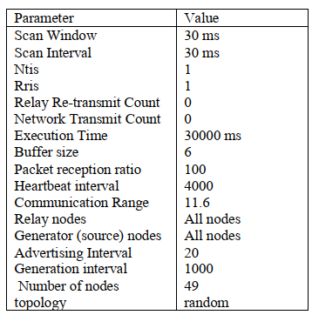

Figure : simulation setting

Default algorithm for a grid network:

a) Here is the topology for grid network in figure 2. And the nodes’ locations are as follows:

Graph with 49 nodes and 84 edges

initial [[22, 6], [4, 6], [30, 6], [8, 6], [2, 6], [6, 6], [12, 6], [1, 6], [27, 6], [9, 6], [12, 6], [16, 6], [6, 6], [3, 6], [25, 6], [10, 6], [24, 6], [13, 6], [9, 6], [21, 6], [9, 6], [27, 6], [16, 1], [25, 6], [5, 6], [4, 6], [4, 6], [13, 6], [10, 6], [22, 6], [19, 6], [3, 6], [6, 1], [21, 6], [26, 6], [16, 6], [9, 6], [7, 6], [18, 6], [1, 6], [15, 6], [10, 6], [2, 6], [12, 6], [21, 6], [25, 6], [5, 6], [5, 6], [23, 6]]

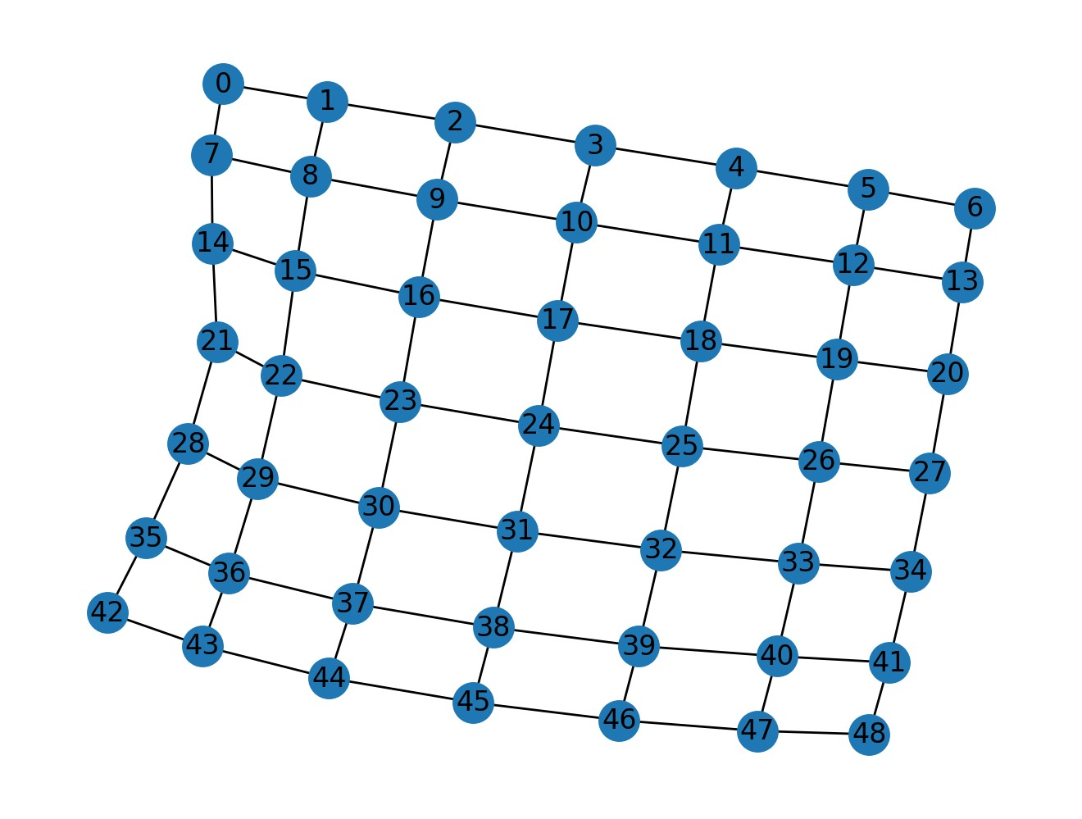

Figure : Grid topology of first scenario

b) show the route of a single packet in the gird network like following:

as we could see, the centered node of topology is 24 and it is our only destination node too. We want to trace a packet generated in node 0 and rout the network till arrives at node 24. We must first check the 0.log file and calculate the route to 24.log file. Also, we need to assign 1 to TOTAL_LOG in the program.

In 0.log file we have:

(generate) 0 14365.7 [24] 14

In 1.log file we have:

(relay) 0 0 14365.77 14 14365.7 8 1

(advertise) 1 14372.17 0 14

In 2.log file we have:

(relay) 1 0 14372.31 14 14365.7 7 1

(advertise) 2 14372.51 0 14

In 3.log we have:

(relay) 2 0 14372.58 14 14365.7 6 1

(advertise) 3 14372.78 0 14

In 10.log we have:

(relay) 3 0 14372.93 14 14365.7 5 1

(advertise) 10 14373.13 0 14

In 11.log we have:

(relay) 10 0 14373.16 14 14365.7 4 1

(advertise) 11 14373.36 0 14

In 18.log we have:

(relay) 11 0 14373.55 14 14365.7 3 1

(advertise) 18 14373.75 0 14

In 25.log we have:

(relay) 18 0 14373.89 14 14365.7 2 1

(advertise) 25 14374.89 0 14

In 24.log we have:

(main) 0 14 14365.7 24 14375.04

And the path that the packet takes in the network is as follows:

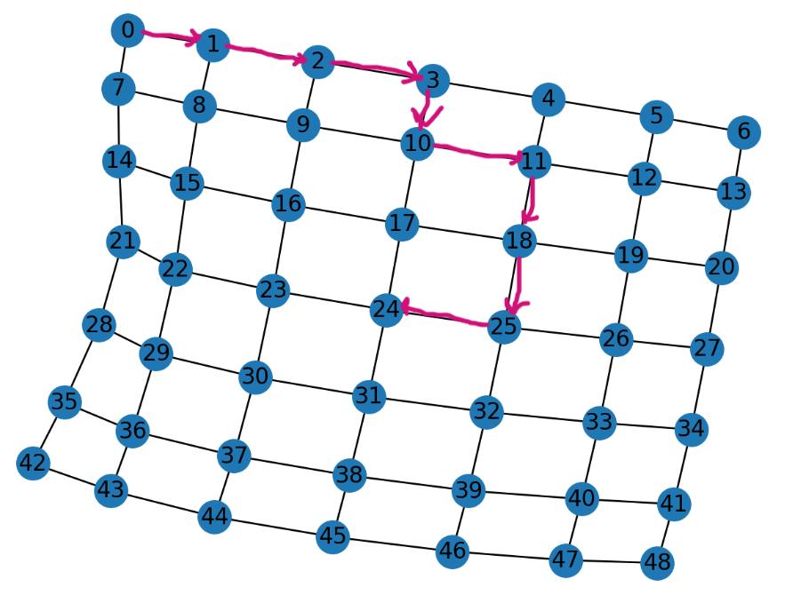

c) In this section we have some of the most important parameters for network analysis.

nodes PDR  [100.0, 100.0, 96.55172413793103, 93.10344827586206, 100.0, 100.0, 100.0, 100.0, 100.0, 96.55172413793103, 100.0, 100.0, 100.0, 100.0, 100.0, 100.0, 100.0, 100.0, 100.0, 100.0, 100.0, 100.0, 96.66666666666667, 100.0, 0, 100.0, 100.0, 96.55172413793103, 100.0, 100.0, 100.0, 100.0, 100.0, 100.0, 100.0, 96.55172413793103, 100.0, 100.0, 100.0, 100.0, 100.0, 100.0, 100.0, 100.0, 100.0, 100.0, 100.0, 100.0, 100.0]

average PDR in the network [99.49952107279694]

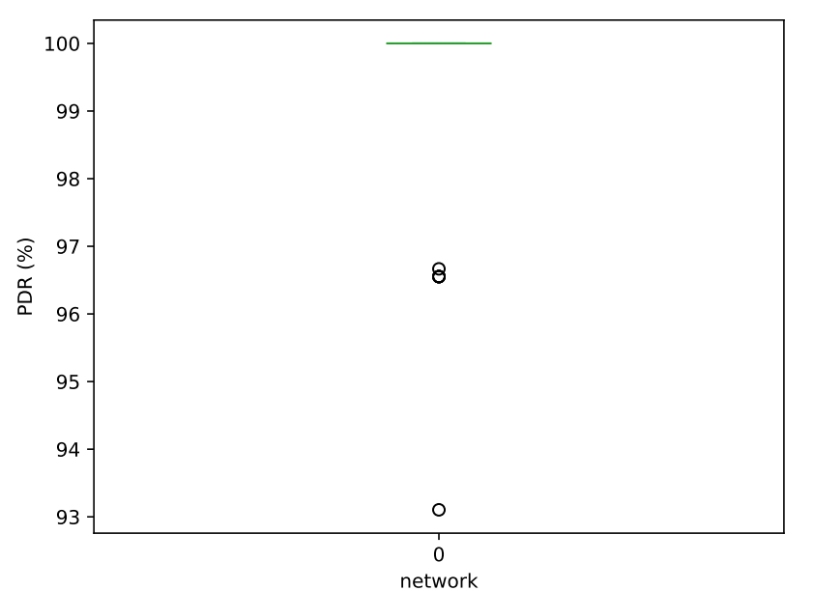

average latency in each node [30.827241379310134, 64.00137931034502, 58.03857142857135, 29.408888888888846, 31.438620689655096, 78.66275862068997, 31.00034482758637, 72.64551724137948, 36.17827586206903, 26.65928571428596, 54.3531034482762, 18.554137931034834, 31.638965517240994, 63.00862068965526, 51.14103448275863, 30.06896551724148, 30.71655172413767, 7.157931034482889, 15.540689655172345, 18.618275862069126, 20.27999999999981, 49.97965517241363, 17.741034482758433, 0.9879310344827461, 0, 1.8593103448278239, 25.819999999999716, 63.541785714285695, 21.033448275862092, 27.007241379310575, 28.39379310344831, 8.307931034482706, 12.58500000000008, 27.65137931034505, 37.210000000000015, 49.09678571428584, 19.142068965517048, 51.50103448275897, 25.256206896551877, 65.7417241379309, 54.302413793103575, 38.126206896551324, 31.67172413793144, 64.4175862068964, 41.60310344827572, 43.44758620689634, 14.923448275862397, 26.718620689655225, 40.44655172413801]

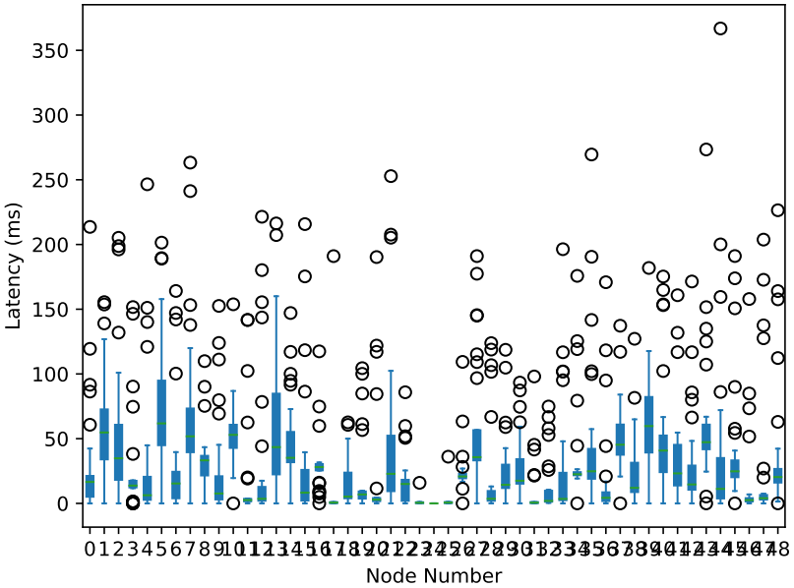

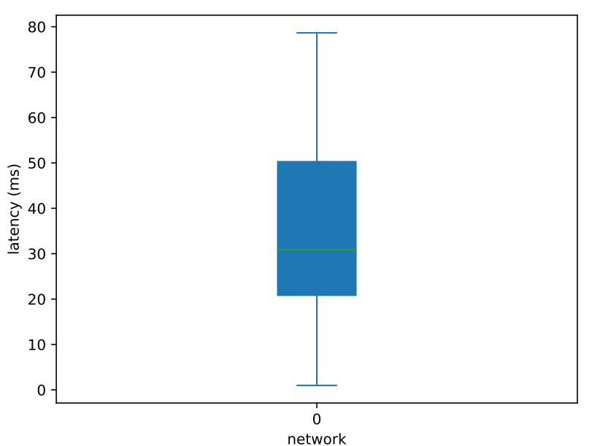

average burst packet loss in each node [[0, 0, 0.03571428571428571, 0.07407407407407407, 0, 0, 0, 0, 0, 0.03571428571428571, 0, 0, 0, 0, 0, 0, 0, 0, 0, 0, 0, 0, 0, 0, 0, 0, 0, 0.03571428571428571, 0, 0, 0, 0, 0, 0, 0, 0.03571428571428571, 0, 0, 0, 0, 0, 0, 0, 0, 0, 0, 0, 0, 0]]

scanning energy in each node [1223.5780800029893, 1214.0454600029545, 1219.2579600029737, 1215.4966200029598, 1220.96766000298, 1213.8536400029539, 1223.6948400029896, 1213.9870800029544, 1215.8635800029613, 1204.7463600029207, 1217.2396800029662, 1202.2527000029118, 1215.9469800029615, 1213.5700800029529, 1220.1003000029766, 1205.3885400029233, 1208.0490000029326, 1193.3372400028793, 1206.1057800029257, 1201.8857400029103, 1220.5840200029784, 1214.8377600029573, 1216.2388800029626, 1194.4881600028834, 1249.9825200030855, 1193.3122200028793, 1217.0311800029656, 1212.9529200029506, 1220.750820002979, 1203.1617600029151, 1206.9564600029287, 1193.795940002881, 1206.3142800029266, 1203.937380002918, 1218.4906800029707, 1214.2956600029554, 1215.3048000029594, 1203.7705800029173, 1218.4156200029706, 1204.2126000029189, 1217.172960002966, 1214.937840002958, 1223.9450400029907, 1213.8870000029542, 1220.1086400029767, 1214.8210800029574, 1219.9001400029758, 1213.2865200029519, 1223.2361400029881]

switching energy in each node [1.758996000000035, 2.3552100000000578, 1.9994580000000444, 2.3123880000000563, 1.9072260000000407, 2.3947380000000593, 1.7458200000000348, 2.391444000000059, 2.223450000000053, 3.004128000000046, 2.1905100000000517, 3.10953600000003, 2.2366260000000535, 2.391444000000059, 1.996164000000044, 2.9678940000000518, 2.724138000000072, 3.741983999999934, 2.872368000000066, 3.1391820000000252, 1.9566360000000427, 2.338740000000057, 2.223450000000053, 3.6398699999999495, 0.023057999999999995, 3.7024559999999402, 2.206980000000052, 2.4457950000000617, 1.9566360000000427, 3.0963600000000318, 2.8493100000000697, 3.6793979999999435, 2.839428000000071, 3.056832000000038, 2.068632000000047, 2.3716800000000586, 2.2893300000000556, 3.0733020000000355, 2.1114540000000486, 3.0469500000000393, 2.1839220000000514, 2.2860360000000552, 1.699704000000033, 2.41450200000006, 1.9467540000000425, 2.2827420000000553, 1.9467540000000425, 2.40462000000006, 1.808406000000037]

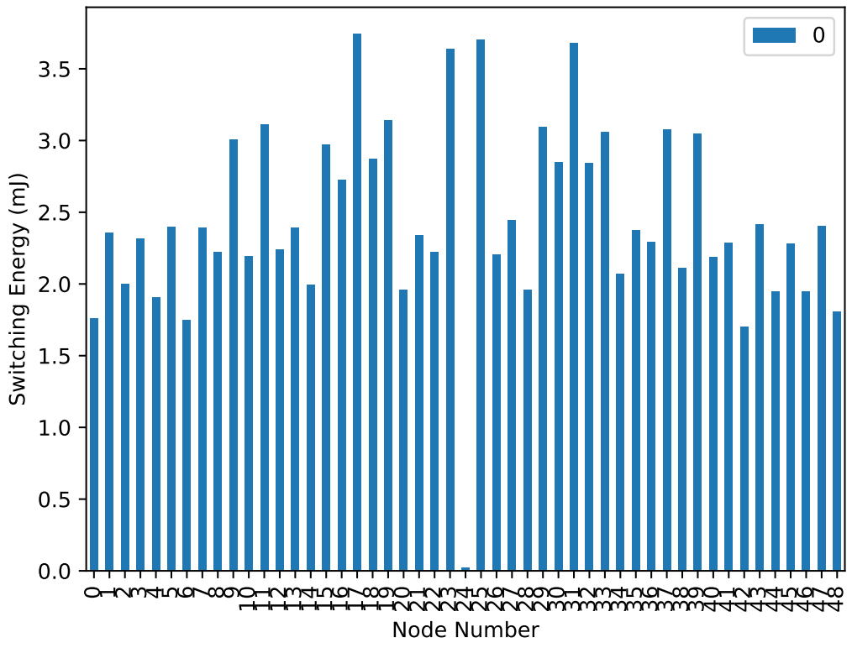

transmitting energy in each node [12.345652799999527, 16.530227999999163, 14.03335439999938, 16.22967839999919, 13.386016799999437, 16.807658399999138, 12.253175999999536, 16.78453919999914, 15.605459999999244, 21.084710399998766, 15.374267999999265, 21.824524799998706, 15.697936799999235, 16.78453919999914, 14.010235199999382, 20.83039919999879, 19.11957839999894, 26.263411199998433, 20.15994239999885, 22.032597599998688, 13.732804799999407, 16.414631999999177, 15.605459999999244, 25.54671599999838, 0.16183440000000002, 25.98598079999835, 15.489863999999255, 17.16215279999911, 13.732804799999407, 21.73204799999871, 19.99810799999886, 25.82414639999836, 19.92875039999887, 21.454617599998734, 14.51885759999934, 16.645823999999152, 16.067843999999205, 21.570213599998727, 14.819407199999311, 21.385259999998745, 15.328029599999269, 16.04472479999921, 11.929507199999563, 16.94637359999913, 13.663447199999412, 16.02160559999921, 13.663447199999412, 16.877015999999134, 12.692440799999497]

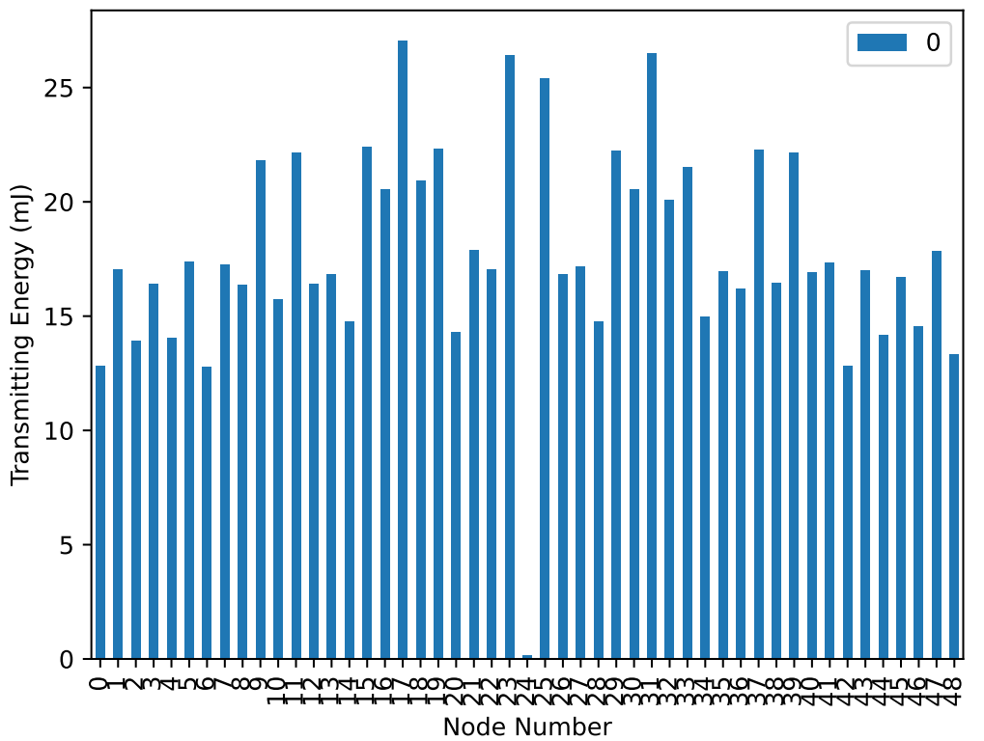

sleeping energy in each node [0.0, 0.0, 0.0, 0.0, 0.0, 0.0, 0.0, 0.0, 0.0, 0.0, 0.0, 0.0, 0.0, 0.0, 0.0, 0.0, 0.0, 0.0, 0.0, 0.0, 0.0, 0.0, 0.0, 0.0, -0.0, 0.0, 0.0, 0.0, 0.0, 0.0, 0.0, 0.0, 0.0, 0.0, 0.0, 0.0, 0.0, 0.0, 0.0, 0.0, 0.0, 0.0, 0.0, 0.0, 0.0, 0.0, 0.0, 0.0, 0.0]

total energy in each node [1236.6694860029831, 1233.028268402952, 1235.2240332029733, 1233.5077320029566, 1236.2498724029763, 1232.605753202949, 1237.142079602985, 1232.9323872029508, 1232.7626856029538, 1227.8122608029128, 1234.0664160029612, 1227.1812456029088, 1233.6147588029569, 1233.306236402954, 1234.5416616029672, 1227.195177602908, 1228.543221602921, 1222.212670802871, 1228.75872600292, 1226.807358002907, 1235.6661108029732, 1231.1935836029418, 1232.5278684029502, 1222.3349076028735, 1250.626112403087, 1224.298833602885, 1233.2645364029538, 1232.5028676029494, 1235.1435348029693, 1226.8365384029075, 1228.7517216029216, 1223.181427202876, 1229.7746976029275, 1227.6273492029131, 1234.2789804029655, 1232.5987488029507, 1233.7106400029581, 1227.4384116029096, 1233.0434784029546, 1227.8067456029112, 1232.6877024029513, 1232.4862068029488, 1237.5034860029862, 1232.7419220029512, 1235.3394384029727, 1232.4916836029513, 1235.596642802972, 1232.1346104029453, 1236.099656402979]

network energy consumption (mJ) 60363.85047374429

Default algorithm for a random network:

After multiple runs of simulation eventually we can find a connected-component graph as our network.

a)

Here is the topology for random network in figure 3. And the node’s locations are as follows:

Graph with 49 nodes and 209 edges

initial [[6, 6], [17, 6], [1, 6], [20, 6], [0, 6], [16, 6], [22, 6], [10, 6], [4, 6], [6, 6], [19, 6], [24, 6], [22, 6], [4, 6], [29, 6], [13, 6], [27, 6], [11, 6], [16, 6], [8, 6], [28, 6], [12, 6], [0, 6], [12, 6], [16, 6], [10, 6], [22, 6], [30, 6], [17, 6], [4, 6], [15, 6], [11, 6], [15, 6], [21, 6], [3, 6], [4, 6], [23, 6], [7, 6], [18, 6], [19, 6], [10, 6], [24, 6], [30, 6], [20, 6], [28, 6], [8, 6], [18, 6], [23, 6], [12, 6]]

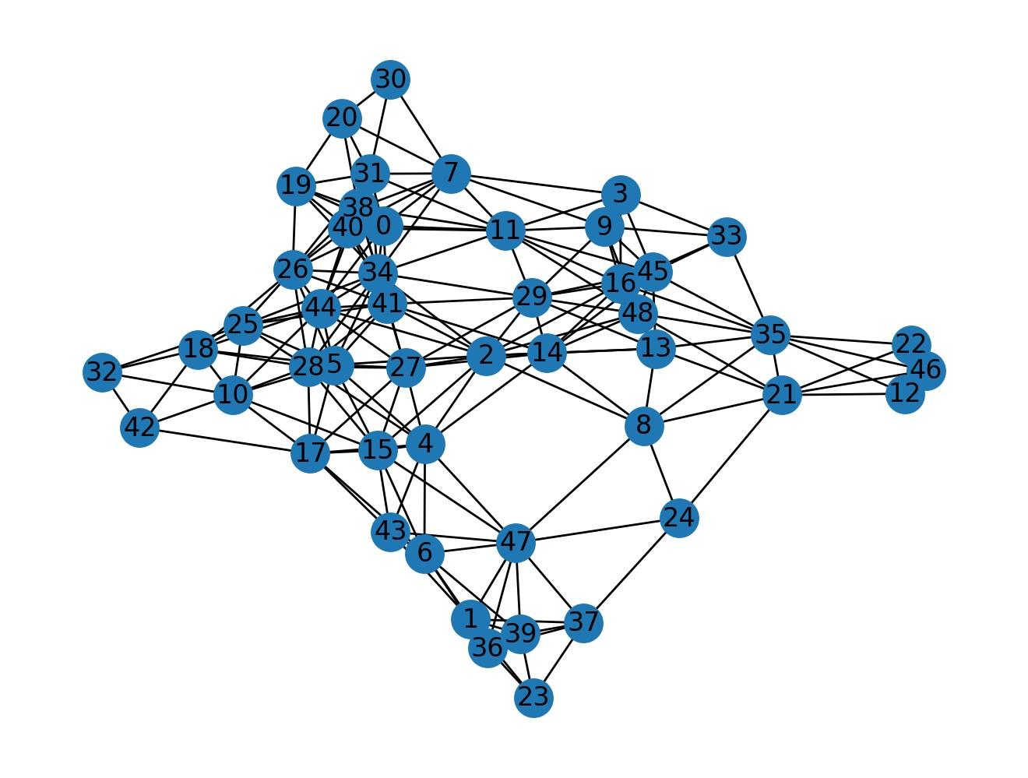

Figure : network topology for random network

b) show the route of a single packet in the gird network like following we do the same for this randomly connected network to find the route of a packet. Here the center node is 2.

c)

nodes PDR  [100.0, 100.0, 96.55172413793103, 93.10344827586206, 100.0, 100.0, 100.0, 100.0, 100.0, 96.55172413793103, 100.0, 100.0, 100.0, 100.0, 100.0, 100.0, 100.0, 100.0, 100.0, 100.0, 100.0, 100.0, 96.66666666666667, 100.0, 0, 100.0, 100.0, 96.55172413793103, 100.0, 100.0, 100.0, 100.0, 100.0, 100.0, 100.0, 96.55172413793103, 100.0, 100.0, 100.0, 100.0, 100.0, 100.0, 100.0, 100.0, 100.0, 100.0, 100.0, 100.0, 100.0]

average PDR in the network [99.49952107279694]

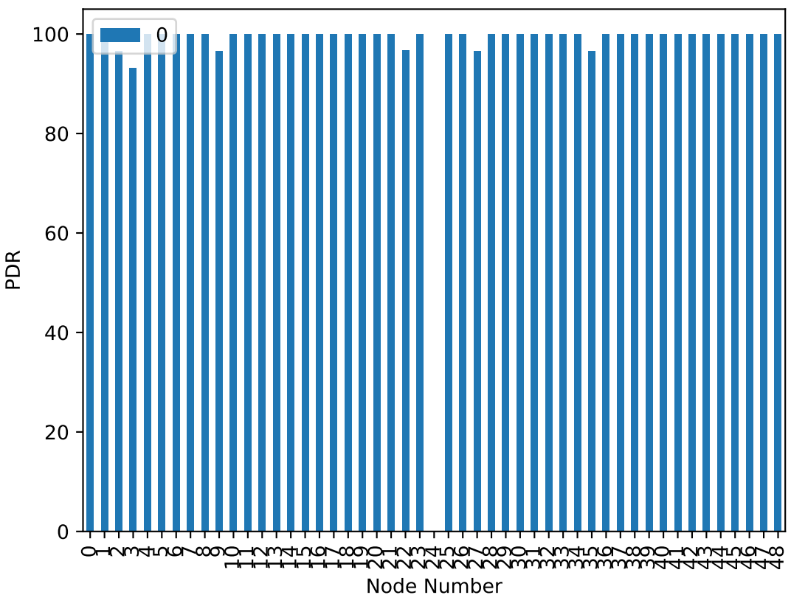

average latency in each node [30.827241379310134, 64.00137931034502, 58.03857142857135, 29.408888888888846, 31.438620689655096, 78.66275862068997, 31.00034482758637, 72.64551724137948, 36.17827586206903, 26.65928571428596, 54.3531034482762, 18.554137931034834, 31.638965517240994, 63.00862068965526, 51.14103448275863, 30.06896551724148, 30.71655172413767, 7.157931034482889, 15.540689655172345, 18.618275862069126, 20.27999999999981, 49.97965517241363, 17.741034482758433, 0.9879310344827461, 0, 1.8593103448278239, 25.819999999999716, 63.541785714285695, 21.033448275862092, 27.007241379310575, 28.39379310344831, 8.307931034482706, 12.58500000000008, 27.65137931034505, 37.210000000000015, 49.09678571428584, 19.142068965517048, 51.50103448275897, 25.256206896551877, 65.7417241379309, 54.302413793103575, 38.126206896551324, 31.67172413793144, 64.4175862068964, 41.60310344827572, 43.44758620689634, 14.923448275862397, 26.718620689655225, 40.44655172413801]

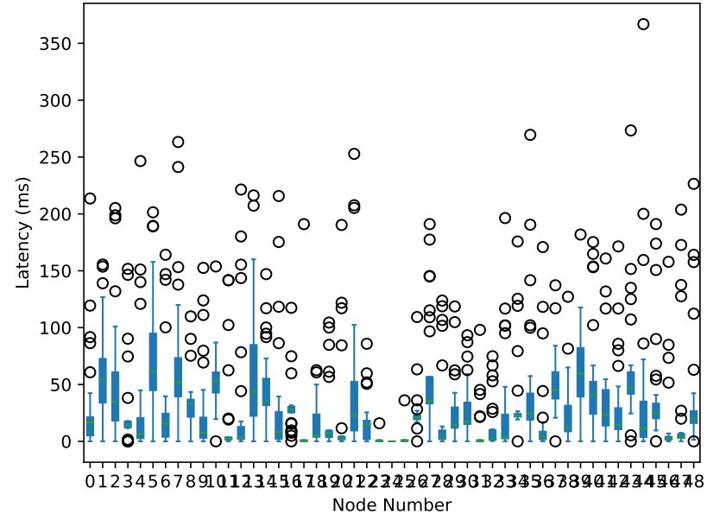

average burst packet loss in each node [[0, 0, 0.03571428571428571, 0.07407407407407407, 0, 0, 0, 0, 0, 0.03571428571428571, 0, 0, 0, 0, 0, 0, 0, 0, 0, 0, 0, 0, 0, 0, 0, 0, 0, 0.03571428571428571, 0, 0, 0, 0, 0, 0, 0, 0.03571428571428571, 0, 0, 0, 0, 0, 0, 0, 0, 0, 0, 0, 0, 0]]

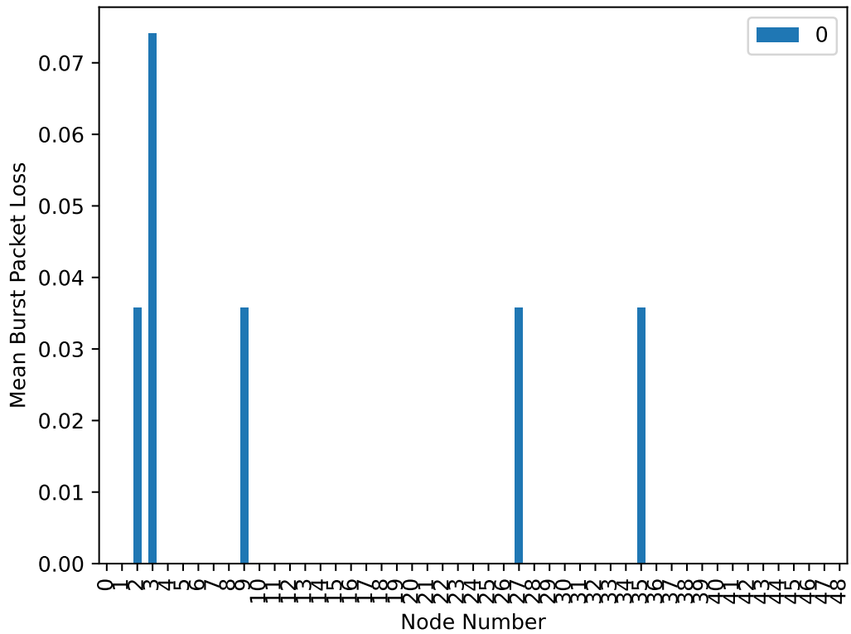

scanning energy in each node [1205.6887800029242, 1217.0145000029654, 1250.6080200030876, 1209.6586200029387, 1193.7459000028807, 1198.1327400028965, 1210.2257400029407, 1205.9723400029254, 1202.7864600029136, 1206.4477200029269, 1204.4377800029197, 1200.4846200029053, 1218.5240400029709, 1201.0851000029074, 1190.9686800028708, 1199.4254400029015, 1197.7824600028955, 1204.7213400029207, 1207.3401000029303, 1213.895340002954, 1216.7059200029644, 1209.5835600029384, 1219.6916400029752, 1227.5395800030037, 1210.4259000029415, 1205.622060002924, 1204.51284000292, 1190.7268200028698, 1198.0910400028968, 1193.2788600028791, 1220.3838600029778, 1207.29840000293, 1213.2531600029517, 1210.551000002942, 1195.5890400028877, 1209.1081800029367, 1216.2555600029625, 1219.3497000029738, 1205.2384200029226, 1216.2722400029627, 1205.2634400029226, 1193.6958600028806, 1212.0188400029472, 1210.2591000029408, 1201.3269600029082, 1198.8082800028992, 1218.9410400029724, 1206.6478800029276, 1196.6315400028914]

switching energy in each node [2.9349540000000567, 2.1674520000000506, 0.023057999999999995, 2.6384940000000685, 3.7288079999999364, 3.399407999999986, 2.595672000000067, 2.905308000000061, 3.129300000000027, 2.885544000000064, 2.981070000000049, 3.224826000000012, 2.0554560000000466, 3.23964900000001, 3.8309219999999202, 3.3236459999999974, 3.392819999999987, 2.984364000000049, 2.7999000000000747, 2.3947380000000593, 2.1575700000000504, 2.6648460000000695, 2.0389860000000457, 1.4954760000000251, 2.5989660000000674, 2.9283660000000573, 2.9678940000000518, 3.8440979999999185, 3.399407999999986, 3.748571999999933, 1.9533420000000425, 2.8163700000000746, 2.4177960000000605, 2.5775550000000664, 3.6003419999999555, 2.7175500000000716, 2.2003920000000523, 2.042280000000046, 2.9316600000000568, 2.210274000000052, 2.951424000000054, 3.6662219999999457, 2.457324000000062, 2.5989660000000674, 3.1589460000000225, 3.3763499999999893, 2.0389860000000457, 2.8262520000000726, 3.5081099999999696]

transmitting energy in each node [20.599207199998812, 15.212433599999278, 0.16183440000000002, 18.51847919999899, 26.17093439999841, 23.859014399998525, 18.217929599999017, 20.391134399998826, 21.96323999999869, 20.25241919999884, 20.92287599999878, 22.633696799998635, 14.426380799999347, 22.741586399998624, 26.887629599998615, 23.32727279999857, 23.812775999998532, 20.94599519999878, 19.651319999998893, 16.807658399999138, 15.143075999999285, 18.703432799998975, 14.310784799999357, 10.496116799999688, 18.241048799999014, 20.552968799998812, 20.83039919999879, 26.98010639999864, 23.859014399998525, 26.309649599998448, 13.709685599999409, 19.766915999998883, 16.969492799999127, 18.086920799999028, 25.269285599998405, 19.073339999998943, 15.443625599999258, 14.333903999999354, 20.576087999998812, 15.512983199999253, 20.7148031999988, 25.739375999998362, 17.246923199999102, 18.241048799999014, 22.171312799998674, 23.70488639999854, 14.310784799999357, 19.836273599998876, 24.62194799999846]

sleeping energy in each node [0.0, 0.0, -0.0, 0.0, 0.0, 0.0, 0.0, 0.0, 0.0, 0.0, 0.0, 0.0, 0.0, 0.0, 0.0, 0.0, 0.0, 0.0, 0.0, 0.0, 0.0, 0.0, 0.0, 0.0, 0.0, 0.0, 0.0, 0.0, 0.0, 0.0, 0.0, 0.0, 0.0, 0.0, 0.0, 0.0, 0.0, 0.0, 0.0, 0.0, 0.0, 0.0, 0.0, 0.0, 0.0, 0.0, 0.0, 0.0, 0.0]

total energy in each node [1229.222941202923, 1234.3943856029648, 1250.7929124030877, 1230.8155932029379, 1223.645642402879, 1225.3911624028951, 1231.0393416029399, 1229.2687824029244, 1227.8790000029123, 1229.5856832029258, 1228.3417260029184, 1226.3431428029041, 1235.0058768029703, 1227.0663354029061, 1221.6872316028694, 1226.0763588029001, 1224.9880560028942, 1228.6516992029196, 1229.791320002929, 1233.0977364029532, 1234.0065660029638, 1230.9518388029376, 1236.0414108029745, 1239.5311728030035, 1231.2659148029404, 1229.1033948029228, 1228.3111332029189, 1221.5510244028685, 1225.3494624028954, 1223.3370816028776, 1236.0468876029772, 1229.881686002929, 1232.640448802951, 1231.215475802941, 1224.4586676028862, 1230.8990700029358, 1233.8995776029617, 1235.7258840029733, 1228.7461680029214, 1233.995497202962, 1228.9296672029216, 1223.1014580028789, 1231.7230872029463, 1231.0991148029398, 1226.657218802907, 1225.8895164028977, 1235.2908108029717, 1229.3104056029265, 1224.7615980028897]

